**Report by**

**E .Bhawani Eswar Reddy**

**Department of Electronics and Telecommunication Engineering(EXTC)**

**TITLE: Mini Project**

**Title of Project:**

**Linear Regression Model using MATLAB GUI**

Software Used:

MATLAB R2017b

___________________________________________________________________________

**Description of Project:**

**Algorithm Used:** Least Squares Gradient Descent.

**Description of the algorithm:**

**Linear Regression** is a machine learning algorithm based on **supervised learning**. It performs a **regression task**. Regression models a target prediction value based on independent variables. It is mostly used for finding out the relationship between variables and forecasting. Different regression models differ based on – the kind of relationship between dependent and independent variables, they are considering and the number of independent variables being used.

Linear regression performs the task to predict a dependent variable value (y) based on a given independent variable (x). So, this regression technique finds out a linear relationship between x (input) and y(output). Hence, the name is Linear Regression.The regression line is the best fit line for our model.

A general univariate Linear Regression problem is considered.

|  |  |  |
| --- | --- | --- |
| **Input(x)** | **Output(y)** | **Model()** |
| x(1) | y(1) | (1) |
| x(2) | y(2) | (2) |
| ….. | …. | ….. |
| x(m) | y(m) | (m) |

First Model hypothesis - Linear Model:



There are infinite possibilities for w. For this,we define a cost function:



Optimal w is the one that minimizes the above cost function. The cost function is called Least Mean Square(LMS).

Using gradient descent:

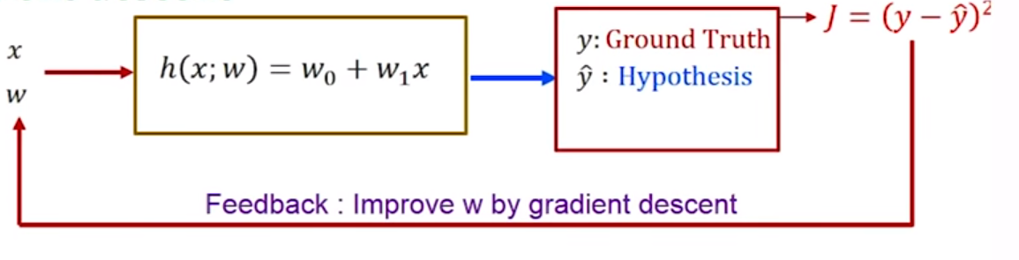

1. Decide on and stopping criterion.
2. Make an initial guess for the weight vector .
3. For any given guess of w, obtain the corresponding output.
4. Calculate J.
5. Improve w by using , where =.
6. Stop when the stopping criterion is met.
7. The final set of w=[w(0),w(1)] obtained are the regression coefficients.

**MATLAB Code:**

methods (Access = private)

% Button pushed function: LoaddatasetincsvformatButton

function LoaddatasetincsvformatButtonPushed(app, event)

[filename, pathname] = uigetfile({'*.csv'},'File Selector');

fullpath = strcat(pathname,filename);

E = readtable(fullpath);

I=csvread(fullpath);

app.UITable.Data = table2cell(E);

x=I(:,1);

y=I(:,2);

plot(app.UIAxes,x,y,'o')

m=51;

alp = 0.1; %Learning rate

ep = 1.e-9; %Stopping tolerance

%Make initial guesses for w

%We will make random guesses for

w1 = rand(1); w0 = rand(1); %Random guesses

%Iterating for w using gradient descent

%We now perform gradient descent on w = [w0, w1] in order to improve w

J(1) = 0.5/m*sum((y-w1*x-w0).^2); %Initial value of J -- the cost function

%err is a variable which denotes the appropriate error variable which we wish to control.

%We have two choices for stopping crtieria

err = 1;

iter = 1;

while(err>ep) %Run if stopping criterion is not satisfied

%The hypothesis function is

yh = w1*x + w0;

%The gradient has two components

DJ0 = (yh-y);

dw0 = -alp*sum(DJ0)/m;

DJ1 = (yh-y).*x;

dw1 = -alp*sum(DJ1)/m;

w0 = w0 + dw0;

w1 = w1 + dw1;

iter = iter + 1;

J(iter) = 0.5/m*sum((y-w1*x-w0).^2);

err = abs(J(iter)-J(iter-1));

%err = norm([dw0,dw1]);

%Create Plots

plot(app.UIAxes2,x,y,'o',x,yh,'r')

answer= ['y=',num2str(w1),'x+',num2str(w0)];

app.EquationofthebestfitlineTextArea.Value = answer;

end

**Output:**

App Design View:

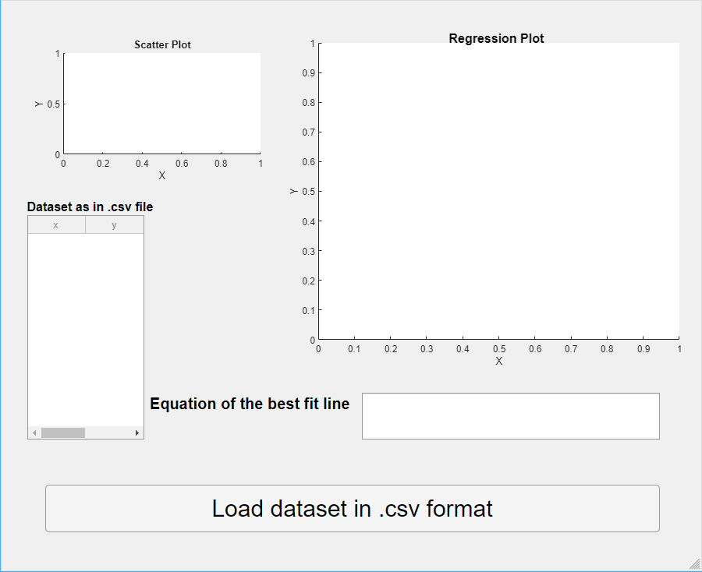

Final Output:

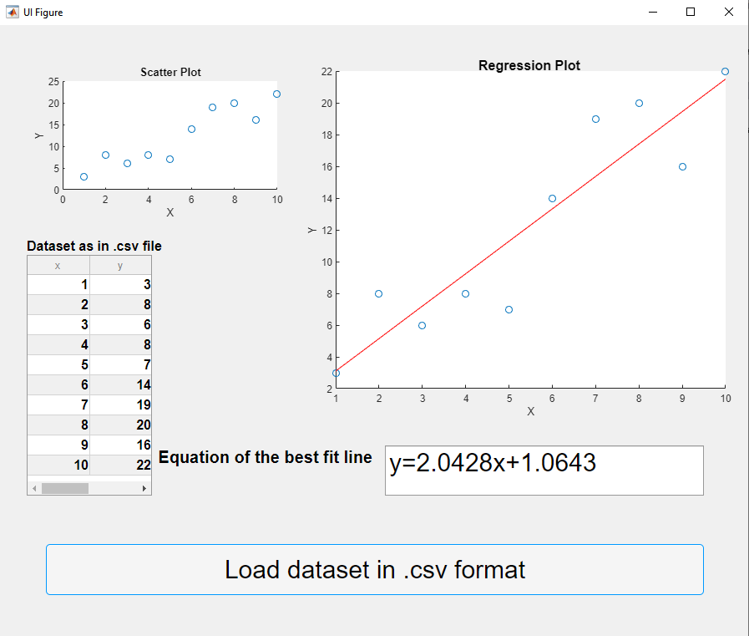

**Conclusion:**

Artificial Intelligence has become prevalent recently. People across different disciplines are trying to apply AI to make their tasks a lot easier. For example, economists are using AI to predict future market prices to make a profit, doctors use AI to classify whether a tumor is malignant or benign, meteorologists use AI to predict the weather, HR recruiters use AI to check the resume of applicants to verify if the applicant meets the minimum criteria for the job, etcetera. The impetus behind such ubiquitous use of AI is machine learning algorithms. The rudimental algorithm that every Machine Learning enthusiast starts with is a linear regression algorithm. It provides a base for us to build on and learn other ML algorithms.